MSSV:

Họ tên SV:

Notes: Filename: Lab04_HoTen_MSSV_Library.docx

**Homework**

**Library Database**

1. **Create Database Library**

SQL Statement

1. **Create tables – Priamry Key – Foreign Key**

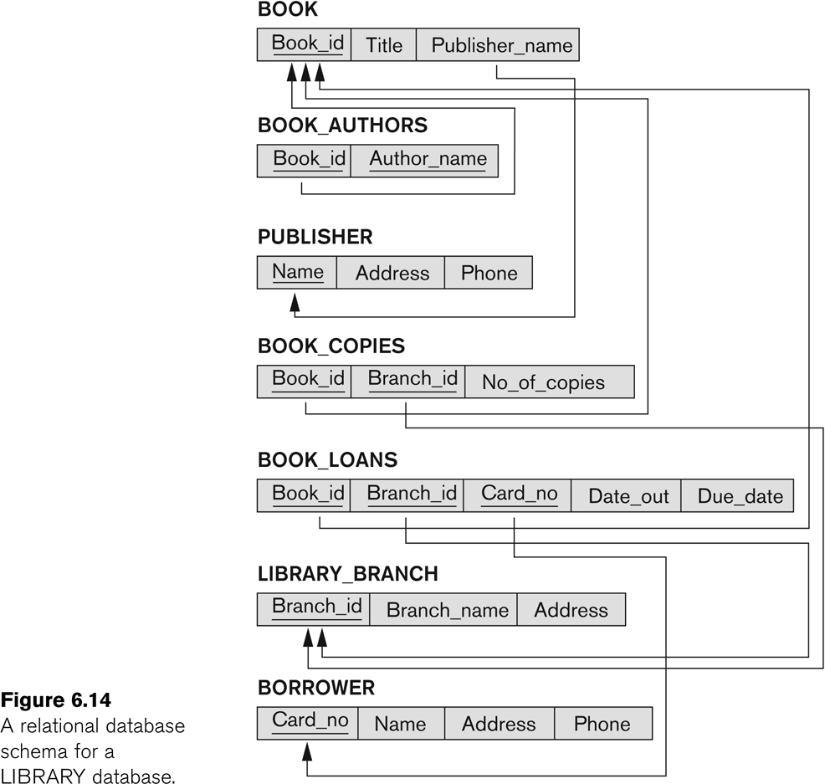

**Table Structure:**

* Publisher

|  |  |  |
| --- | --- | --- |
| **Field Name** | **Data Type** | **Null** |
| **Name** | VARCHAR(20) | NOT NULL |
| Address | VARCHAR(30) |  |
| Phone | VARCHAR(10) |  |

* Book

|  |  |  |
| --- | --- | --- |
| **Field Name** | **Data Type** | **Null** |
| **Book_ID** | SMALLINT | NOT NULL |
| Ttile | VARCHAR(30) | NOT NULL |
| Publisher_Name | VARCHAR(20) |  |

* Library_Branch

|  |  |  |
| --- | --- | --- |
| **Field Name** | **Data Type** | **Null** |
| **Branch_ID** | SMALLINT | NOT NULL |
| Branch_Name | VARCHAR(20) | NOT NULL |
| Address | VARCHAR(30) |  |

* Book_Authors

|  |  |  |
| --- | --- | --- |
| **Field Name** | **Data Type** | **Null – PK** |
| **Book_ID** | SMALLINT | NOT NULL |
| **Author_Name** | VARCHAR(20) | NOT NULL |

* Borrower

|  |  |  |
| --- | --- | --- |
| **Field Name** | **Data Type** | **Null – PK** |
| **Card_NO** | SMALLINT | NOT NULL |
| Name | VARCHAR(20) |  |
| Adress | VARCHAR(30) |  |
| Phone | VARCHAR(10) |  |

* Book_Copies

|  |  |  |
| --- | --- | --- |
| **Field Name** | **Data Type** | **Null – PK** |
| **Book_ID** | SMALLINT | NOT NULL |
| **Branch_ID** | SMALLINT | NOT NULL |
| No_Of_Copies | SMALLINT |  |

* Book_Loans

|  |  |  |
| --- | --- | --- |
| **Field Name** | **Data Type** | **Null – PK** |
| **Book_ID** | SMALLINT | NOT NULL |
| **Branch_ID** | SMALLINT | NOT NULL |
| **Card_NO** | SMALLINT | NOT NULL |
| Date_Out | DATETIME |  |
| Due_Date | DATETIME |  |

SQL Statement

1. **Insert Data**

* Publisher

|  |  |  |
| --- | --- | --- |
| Name | Address | Phone |
| Amazing Books | 9012 Great Rd | 333-3333 |
| Plume | 1234 Cool Ave | 555-5555 |
| Random House | 5678 Neat St | 444-4444 |

* Book

|  |  |  |
| --- | --- | --- |
| Book_ID | Title | Publisher_Name |
| 1 | The Lost Tribe | Random House |
| 2 | Farook | Random House |
| 3 | Carrie | Plume |
| 4 | The Dark Tower VII | Plume |
| 5 | Red Dawn | Amazing Books |
| 6 | Zepplin | Amazing Books |

* Library_Branch

|  |  |  |
| --- | --- | --- |
| Branch_ID | Branch_Name | Address |
| 1 | Sharpstown | 4321 Wonder Road |
| 2 | Central | 9876 Flower St |

* Book_Authors

|  |  |
| --- | --- |
| Book_ID | Author_Name |
| 1 | Master Nook |
| 2 | Jardumba Nartangula |
| 3 | Stephen King |
| 4 | Stephen King |
| 5 | John Smith |
| 6 | Yasunori Mitsugi |

* Borrower

|  |  |  |  |
| --- | --- | --- | --- |
| Card_No | Name | Address | Phone |
| 1 | John Doe | 1234 Plain St | 532-2432 |
| 2 | Jane Doe | 1234 Plain St | 532-2432 |
| 3 | Mike Jackson | 1111 nowhere | 222-2222 |

* Book_Copies

|  |  |  |
| --- | --- | --- |
| Book_ID | Branch_ID | No_Of_Copies |
| 1 | 1 | 10 |
| 1 | 2 | 10 |
| 2 | 1 | 10 |
| 2 | 2 | 10 |
| 3 | 1 | 10 |
| 3 | 2 | 10 |
| 4 | 1 | 10 |
| 4 | 2 | 10 |
| 5 | 1 | 10 |
| 5 | 2 | 10 |
| 6 | 2 | 10 |

* Book_Loans

|  |  |  |  |  |
| --- | --- | --- | --- | --- |
| Book_ID | Branch_ID | Card_No | Date_Out | Due_Date |
| 1 | 1 | 1 | 12/15/2005 | NULL |
| 1 | 2 | 1 | 11/24/2005 | NULL |
| 2 | 1 | 2 | 12/15/2005 | NULL |
| 2 | 2 | 2 | 11/24/2005 | NULL |
| 3 | 1 | 3 | 12/15/2005 | NULL |
| 3 | 2 | 3 | 11/24/2005 | NULL |
| 4 | 1 | 1 | 12/15/2005 | NULL |
| 4 | 2 | 1 | 11/24/2005 | NULL |
| 5 | 1 | 2 | 12/15/2005 | NULL |
| 5 | 2 | 2 | 11/24/2005 | NULL |
| 6 | 1 | 3 | 12/15/2005 | NULL |
| 6 | 2 | 3 | 11/19/2009 | NULL |

SQL Statement

1. **Queries** (include result queries)
   1. How many copies of the book titled The Lost Tribe are owned by the library branch whose name is "Sharpstown"?

**Query**:

**Result**:

* 1. How many copies of the book titled The Lost Tribe are owned by each library branch?

**Query**:

**Result**:

* 1. Retrieve the names of all borrowers who do not have any books checked out.

**Query**:

**Result**:

* 1. For each book that is loaned out from the "Sharpstown" branch and whose DueDate is today, retrieve the book title, the borrower's name, and the borrower's address.

**Query**:

**Result**:

* 1. For each library branch, retrieve the branch name and the total number of books loaned out from that branch.

**Query**:

**Result**:

* 1. Retrieve the names, addresses, and number of books checked out for all borrowers who have more than five books checked out.

**Query**:

**Result**:

* 1. For each book authored (or co-authored) by "Stephen King", retrieve the title and the number of copies owned by the library branch whose name is "Central".

**Query**:

**Result**:

**END**